Zambia

## Respect for rule of law (ROL) data

The data set shows the data on the respect of the rule of law for the country.

## # A tibble: 19 x 5  
## country iso3c date ruleOfLaw ruleOfLawCategory4   
## <chr> <chr> <dbl> <dbl> <chr>   
## 1 Zambia ZMB 1996 -0.532 ROL moderately disrespected  
## 2 Zambia ZMB 1998 -0.371 ROL moderately disrespected  
## 3 Zambia ZMB 2000 -0.482 ROL moderately disrespected  
## 4 Zambia ZMB 2002 -0.311 ROL moderately disrespected  
## 5 Zambia ZMB 2003 -0.390 ROL moderately disrespected  
## 6 Zambia ZMB 2004 -0.490 ROL moderately disrespected  
## 7 Zambia ZMB 2005 -0.520 ROL moderately disrespected  
## 8 Zambia ZMB 2006 -0.540 ROL moderately disrespected  
## 9 Zambia ZMB 2007 -0.525 ROL moderately disrespected  
## 10 Zambia ZMB 2008 -0.408 ROL moderately disrespected  
## 11 Zambia ZMB 2009 -0.476 ROL moderately disrespected  
## 12 Zambia ZMB 2010 -0.490 ROL moderately disrespected  
## 13 Zambia ZMB 2011 -0.456 ROL moderately disrespected  
## 14 Zambia ZMB 2012 -0.365 ROL moderately disrespected  
## 15 Zambia ZMB 2013 -0.268 ROL moderately disrespected  
## 16 Zambia ZMB 2014 -0.237 ROL moderately disrespected  
## 17 Zambia ZMB 2015 -0.230 ROL moderately disrespected  
## 18 Zambia ZMB 2016 -0.301 ROL moderately disrespected  
## 19 Zambia ZMB 2017 -0.327 ROL moderately disrespected

## Respect for rule of law (ROL) trend

The plot shows the trend of the respect for the rule of law for the country.

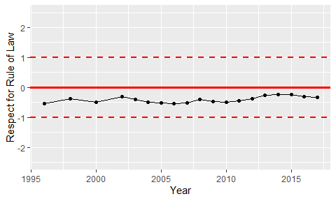

Trend of the Respect for the Rule of Law